Los Apuntes de la presentación de la unidad 3:
*Parte 1: Las formas de los verbos de –er

a) Remember that infinitive verbs have one of three endings in Spanish: _______, _______, _______

b) Remember that in English, an infinitive is made up of two words starting with: ________
c) Remember that if you to give an infinitive verb a subject and a tense, you must __________________.
d) Remember that you must take off the ending of the verb, which leave the part called the: ________
e) Remember the endings for –ar verbs are: _______, _______, _______, _______, _______
f) Remember the endings for –er verbs are: _______, _______, _______, _______,_______
Conjugate these verbs: | to eat | to drink
yo
tú
él, ella, usted (Ud.)
nosotros
ellos, ellas, ustedes (Uds.)

*Parte 2: Unas preguntas y respuestas de la unidad:

What do you eat for breakfast?
What do you drink for lunch?
Do you eat soup for dinner?
Do you drink coffee at breakfast?
How often do you drink tea?

Parte 3: La frecuencia

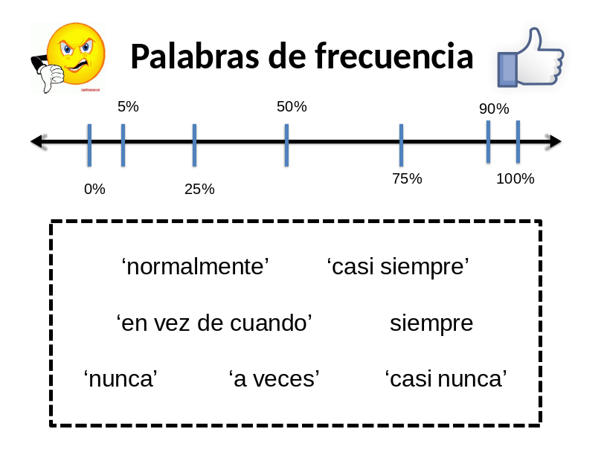
¿Cuáles palabras son correctas?
100% _________________________
90% __________________________
75% __________________________
50% __________________________
25% __________________________
5% ___________________________
0% ___________________________

