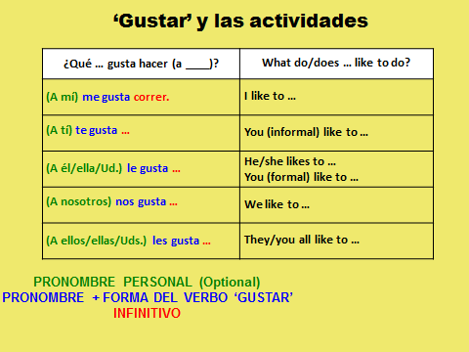
Here is the structure to talk about other people’s likes:
¿Qué _____ gusta hacer a _____?

______ __________________ ______ ____________ ________________.
My mom (she) likes to….

______ __________________ ______ ____________ _______________.
My friends (they) like to…

______ ______________ ___ ______ _____ ______ __________ ________.
My friends and I (we) like to...

